***Newcastle Studio Potters Inc celebrated our 55th Anniversary in 2023***

Newcastle Studio Potters Inc

57 Bull Street, Cooks Hill 2300

Phone 49293677

*2026 Submission Form for Back to Back Galleries Exhibition Space*

**A *Applicant – clay artist***

Name

Address

Tel numbers: (h) (m)

e-mail:

**B *Additional artists*** *(names and medium if not clay – use additional page if needed)*

1.

2.

3.

4.

5.

**C *Exhibition title/theme***

**D** *Brief description of work that will constitute the exhibition. Please note that this is a clay based gallery.* *The major component of the exhibition should be work in clay.* Plinths are provided for the display of clay pieces. ***NOTE:*** **NO SCREWS, NAILS OR PINS ARE TO BE ATTACHED DIRECTLY INTO THE EXHIBITION SPACE WALLS.** Please only use the hanging system that is supplied*.* ***NOTE*: CLAY PIECES MUST HAVE A SMOOTH, NON-SCRATCH BASE SO AS NOT TO DAMAGE THE PLINTHS.**

**E Please include short artist statement and images of each artist’s work.**

**F *Preferred exhibition******month****: We open February 13, 2026*

First Choice:

Second Choice:

Third Choice:

**2026**

Feb 13 – March 1 1 Not Available

Mar 6 – 22 2

Mar 27 – April 12 3 Writers Festival

*Easter Friday 3…*

Apr 17 – May 3 4

*School Holidays April 7 - 17*

May 8 – 24 5 Not Available

May 29 – June 14 6 Not Available

June 19 – July 5 7 TAFE Graduates

*School Holidays July 6 - 17*

July 10 -26 8

July 31 - 16 9

Aug 21– Sept 6 10 Not Available

Sept 11 – 27 11 NSP Inc Members + Artists

*School Holidays Sept 28 – Oct 19*

Oct 2 –18 12 Not Available

Oct 23 – Nov 8 13

Nov 13 – 29 14

Dec 4 – 20 15 Xmas Takeaway

**G Additional information that you would like to provide.**

**Your complete submission must include the following materials:**

* **Completed submission form.**
* **Images of at least two works for each artist in the exhibition.**
* **A short resume for each artist in the exhibition.**

**Fees**

* Gallery fees are $600 (+$200 returnable bond) for three weeks. There is no commission.
* Artists are responsible for all exhibition expenses and gallery staffing (unless other arrangements are made with the Gallery Officer)

**Timeline:** The Gallery Sub-Committee will review submissions in early August with the goal of contacting exhibitors with decisions by mid-August 2025.

**Submissions should be delivered to:**

**Gallery Officers**

**Newcastle Studio Potters Inc**

**57 Bull Street**

**Cooks Hill NSW 2300**

**Or sent electronically to** [**b2bgalleries@gmail.com**](mailto:b2bgalleries@gmail.com) **or**

**dspalding46@gmail.com**

Feel free to contact the Gallery Officers at any time if you have questions.

**Gallery Information 2026**

**Gallery officers: Denise Spalding 0458285201** [**dspalding46@gmail.com**](mailto:dspalding46@gmail.com)

**Melanie Channel**

**Publicity Officer: Marian Marcatili** [**marian.marcatili@gmail.com**](mailto:marian.marcatili@gmail.com)

**Fee Structure and Payment**

* The gallery rent is $600 for three weeks.
* An additional bond of $200 applies. This will be refunded at the completion of the exhibition, provided there has been no damage.
* The contract is signed and a deposit of $200 is taken three months before the exhibition opens; and the remaining $600 is paid when the gallery keys are provided.
* Payments should be made in cash, by cheque or by direct deposit. When paying by cheque please make payable to “Newcastle Studio Potters Inc.” Receipts will be issued.

**Publicity - Invitations**

Artists are asked to provide the following information for publicity, web-site, Facebook, archival and display purposes.

* A short artist statement concerning the artists and the work to be exhibited. This will be used for the media release.
* 20 invitations (DL size) three weeks prior to the opening of the exhibition.
* 2 or more images (jpeg) of artwork for advertising.
* Images for advertisement should be 300dpi and measure about 20cm by 20cm.

Two weeks prior to each exhibition, the Publicity Officer will send out the media release and post on the NSP Facebook page, Instagram, HAN, Independent Galleries and TACA newsletter. One week prior to the opening, electronic invitations will be sent to over 650 e-mail addresses. An advertisement is put into the Free Newcastle Weekly Magazine as well. Additional promotional opportunities are continually being sought.

Invitations must be professionally prepared, the size of a DL envelope and our logos must be included. Printed invitations and media release wording including name and phone number of contact person, must be provided at least three weeks prior to the opening.

Any additional publicity is the responsibility of the artist.

COVID 19 Protocol

Depending on the NSW Government restriction at the time, a COVID 19 protocol may be in place.

**Setting up / Dismantling**

*Set Up:* Exhibitions may be set up from the Tuesday prior to the opening.

*Cleaning:* Although the Gallery Officer will ensure the previous exhibitors have left the gallery in good order, additional cleaning may be needed. The gallery provides cleaning equipment as well as paint, trays, rollers and brushes.

*Hanging/Presentation* The gallery is equipped with hanging rails and wire hanging cords. Plinths are available.

*Reception* Exhibitors are responsible for organizing, paying for and overseeing the opening reception – normally from 6-8pm on the first Friday of the exhibition.

*Kitchen* The kitchen is available for use. The kitchen is to be kept clean and tidy. The wine glasses must be washed and replaced into the boxes supplied.

*Dismantling* The exhibition is to be taken down after 5pm on the last Sunday or the following Monday and the keys returned. The gallery will be inspected prior to the deposit being refunded. All uncollected work must be taken by the artist.

**Gallery Sitting Instructions**

*Opening hours:* The gallery is open Friday to Sunday, from 11 am until 5 pm. **The gallery must be open at these times.** It is possible to extend these hours on consultation with the Gallery Officers.

*Sales and receipt books:* Exhibitors must provide their own receipt books and any other documents required for the sale of items. Exhibitors are responsible for the delivery of sold work at the close of the exhibition. No work (sold or unsold) may be left in the gallery after the exhibition closes. Exhibitors are responsible for the wrapping of sold work.

*Catalogue:* Exhibitors are responsible for the preparation and printing of the catalogue or floor sheet. **Individual cards with each item will replace the paper catalogues if COVID-19 Protocol is still in place.**

*Arrival / Closing:* On arrival, the lights are turned on and the flags put out. The reverse on closing Please note that the Gallery Shop has ceiling lights and a light box that must be switched on.

*Visitor numbers:* Daily visitor numbers are to be recorded. **The COVID -19 QR register may be a requirement.**

*Smoking:* The building and grounds are non-smoking.

*Phone:* Each call is 50 cents.

*Workshop:* The workshop area is for the use of NSP members only. However, exhibitors may access the toilet during an exhibition.

*Radio:* Radios can only be played in the office. Playing it in public areas can incur a fine for infringement of copyright laws.

*Dress:* Suitable dress is expected.

**Gallery Shop - Sales**

During the exhibition, the Gallery Shop is the responsibility of exhibitors.

Each item on sale in the Gallery Shop should be marked with the artist’s initials, a number and a price. If it is not marked it cannot be sold.

* Use the receipt book marked “Gallery Shop”. Include the names of purchaser plus a phone number. Also the artist code, the number of the piece and price. Note “cash” or “direct deposit” Give the top copy to the purchaser and leave the other in the book.
* We accept cash and Direct Deposit via the phone banking app. If sale is via phone banking the receipt on the phone, the phone number and the phone owner’s name must be recorded.

Example:

|  |  |  |  |  |  |  |  |  |
| --- | --- | --- | --- | --- | --- | --- | --- | --- |
| Date | Artist’s Name/code | Item details | Item # | Price | Receipt # | Purchaser | Phone No. | Gallery Sitter |
| 05/04/12 | AHI | Blue Bowl | 12 | $30 | 15 | E. Brown | 04 933 67271 | B. Smith |

* Leave monies received in the cash box for collection by the Assistant Treasurer.
* The right-hand drawer is reserved for The Gallery Shop.
* The tissue paper and bags are reserved for The Gallery Shop

**Overview of Exhibition Checklist**

* 3 months before opening Meeting to sign contract and pay $200 deposit.
* 4 to 6 weeks before opening Arrange printing of invitations and guest speaker for opening.
* 2 weeks before opening Media releases distributed and postings put on websites.
* 1 week before opening Arrange for keys. Electronic invitations distributed.
* Tuesday before opening Collect keys and make rest of rent payment.
* Tuesday – Thursday Set up the exhibition, prepare for reception.
* During the exhibition The gallery is open 11am-5 pm, Fri, Sat, Sun.

**Gallery Floor Plan**

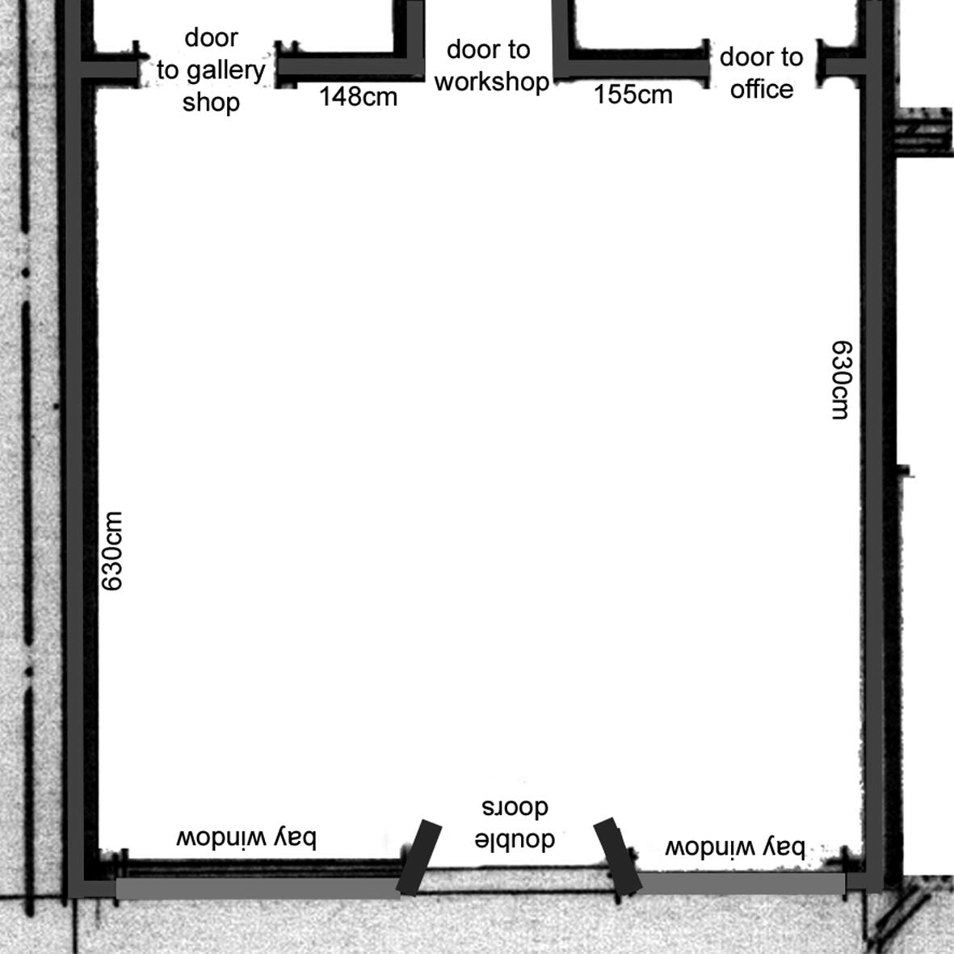

**Gallery Logos**

The following logos should be used on your promotional material. Resize them to fit your needs.

 * * 